Taunton Youth Soccer Scholarship Application 2021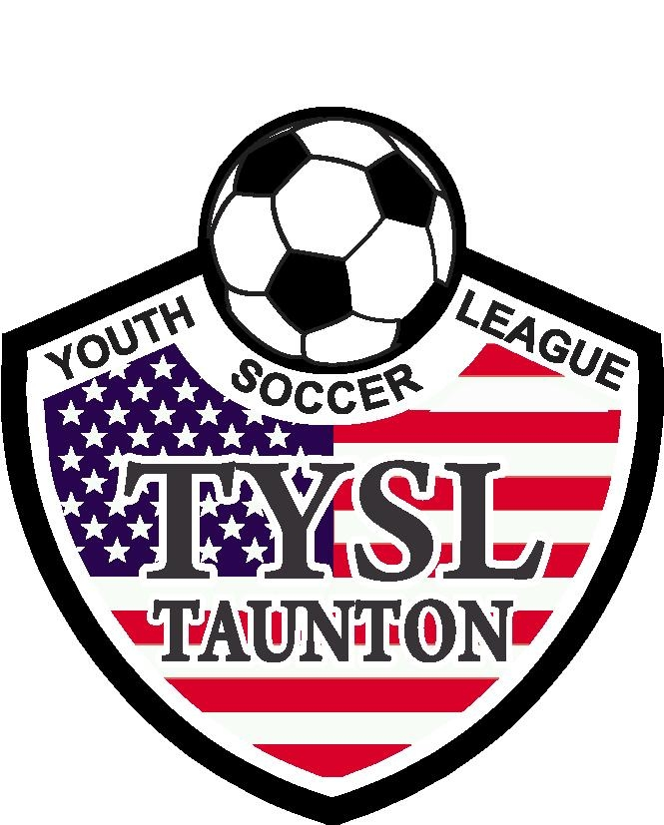

I. Student Information:

Name: _______________________________________________________________________
Address: _____________________________________________________________________
Email:________________________________________________________________________Cell:__________________________________________________________________________
High School: _______________________

Colleges you have applied to or have been accepted at:

______________________________________________________________________________

Major Field of Study: ___________________________________________________________

Class Rank: _____ Class Size: _______ SAT scores: EBRW______Math______
ACT Composite Score: ____________

GPA _____________ on a ______________ scale

National Honor Society (currently): yes_____ no_____

Total Seasons of experience with TYSL: Fall _____Winter____ Spring____ Summer ____

Years as: Volunteer ________ Referee ___________ Coach __________________

Extracurricular/Sports/ Activities /Work Experience (attached list permitted):

_________________ _________________ _________________ _______________________

_________________ _________________ _________________ _______________________

_________________ _________________ _________________ _______________________

_________________ _________________ _________________ ______________________
II. Family Background:

Parent Names Occupation Place of Employment
_________________________ __________________ ________________________
_________________________ __________________ ________________________

Siblings Age School/College Name
_____________________ ________ ___________________________________
_____________________ ________ ___________________________________
_____________________ ________ ___________________________________

“Parent signature” verifies the above information and releases information to the scholarship committee.

___________________________________________ _______________________________
Parent’s Signature Date

___________________________________________ _______________________________
Student’s Signature Date

** Include a typed essay (500-750 words):
Please describe your experience with TYS and what this scholarship means to you.

Along with completed application, one letter of recommendation, and an official high school transcript must be included.

Completed applications to be mailed to:
Nicole Constantino
Registrar @ Taunton Youth Soccer
1095 Glebe St
Taunton, MA 02780
Or Emailed to: nconstantino81@yahoo.com
Subject line: TYS Scholarship
DEADLINE : May 1st, 2021 (postmarked)

